Minutes for Guthrie County EMS Advisory Council
Chairman Mark Laughery; Vice Chairman Tim McDermott; Secretary Jotham Arber

October 25, 2023 regular meeting

COUNCIL MEMBERS – X by name was present at the meeting
Matt Richter, Adair EMS |  | Alexi Olsen, Panora EMS |  | Sean Bovinett, Stuart Rescue | Yes
Amanda Waltz, GC Hospital |  | Jeremy Cooper, GC EMA | Yes | Mike Dickson, Supervisor | Yes
JD Kuster, Supervisor | Yes | Jotham Arber, GC Public Health | Yes | Tim McDermott NE Region
Don Schwartz, NW Region |  | Tammy Bireline, SW Region |  | Mark Laughery, Central Reg | Yes
Stacy Richter, SE Region |  | Julie Neilsen, Bayard EMS

Guests – Jo Rasmussen

Call to Order - Mark Laughery, Chairman opened the meeting at 7:10 p.m.

Roll Call of Council members via sign in sheet

New Business
Group discussion on the draft proposal.
Draft Proposal for EMS Services/ in Guthrie County
Purpose:
To provide the best coverage of EMS Services for all residents in Guthrie County, move the financial liability that is currently with cities to the county level, and to develop and reinforce an EMS model that is sustainable long-term to best support all residents in Guthrie County as it grows and changes.

Current Challenges
- Large area of uncovered territory in the western part of Guthrie County
- Long response times for uncovered area and while ambulances are transporting patients out of county leading to worse outcomes
- Financially unsustainable burdens on cities causing stress on city budgets
- Lack of in-county EMS personnel and first responder groups
- Lack of consistent protocols and equipment
Current Ambulance response area within 10 minutes from stations
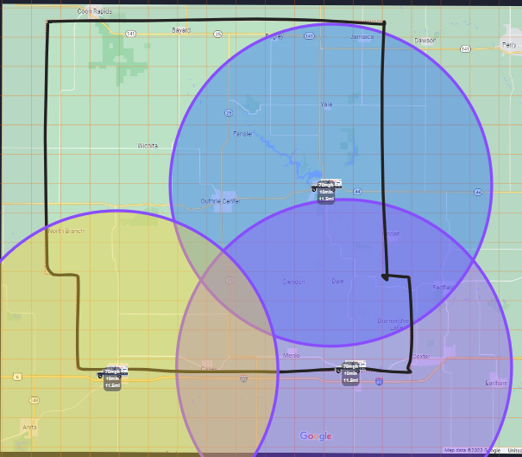

Solutions Proposed
- Develop a countywide service with the participation from all current services and cities over the next 5 years.
- Staff additional ambulance crews to:
  - Decrease response times through on duty ambulance depth and placement.
  - Decrease staff fatigue through call rotation.
  - Decrease reliance on outside services during high call volumes or multi-patient events.
- Develop EMS first responders within each fire department in the county.
  - Help with recruitment and retention.
  - Provide training and other operational support.

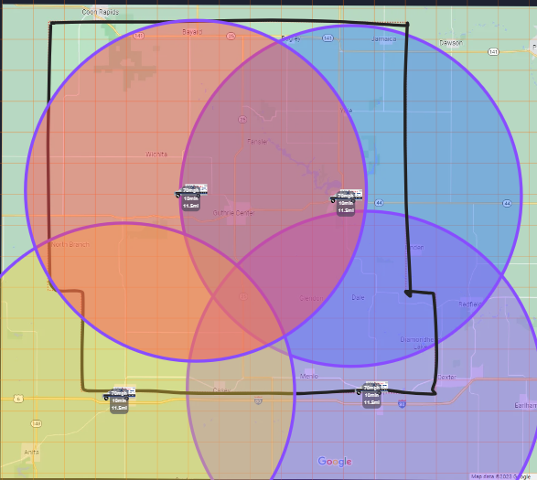

Proposed EMS Services timeline for Guthrie County Residents
Year 1-3
- Establish and approve a county wide EMS tax.
- Hire EMS coordinator for the County.
- Initiate 28E agreement with existing Ambulance Services for county subsidization of operational expenses (services will still bill for services) and add additional on duty crews and roster depth.
- Align Medical Direction under single Countywide Medical Director.
- Align all ambulance services protocols and equipment.
- Initiate a county wide training program.
- Develop, grow, and/or support EMS first responders within fire departments in every town, township, or fire district and tie them back to county services to alleviate administrative strain at the fire department level.
Year 4 and 5
- Align billing and all administrative functions under county service.
- Develop long term 28E agreements with cities to keep ambulances in cities and pay for use of facilities/ equipment along with hiring all EMS staff under new countywide service.
Year 5-10 continued taxes for countywide service
- Replace, purchase, and upgrade equipment to county equipment.
- Reassess number of on-duty ambulances, and placement thereof, to best support county needs.

QUESTIONS – COMMENTS
- Discussion regarding Stuart City Council meeting in September.
- Arber noted that they will meet with two city council members – Kristen Renslow, Kalbaugh will represent City with Jotham.
- The group consensus to send out the proposal to all cities/towns in Guthrie County.
- Need to get the city council to list their concerns and what their needs are and with this proposal.
- Hard to get grants for the current EMS services because of the population they are serving. Will be easier to apply for grants for a complete county run services.
- Arber noted that KCCI TV 8 news will be doing some interviews regarding the current EMS. Panora EMS (John) Director, Jotham Arber and Mike Dickson and Stuart? Jotham will send out talking points for the interview.
- Educational meeting with public to educate
  - Panora and Stuart
  - Then the small communities – give the education the residents that will get services

28 E Agreements –
- Legal questions – the county attorney should be able to assist with a draft but each city would have their own council attorney review and approve.
- 5 years for 28E – timeline for all the transition. Jotham has draft from Buchanan County to start with. Kossuth County draft. He also has ballot language from Kossuth county.

Arber will send out the draft to all township clerks and they will get it out to the trustees. Also the cities in the county. Jotham wants to meet with the Fire Chiefs to help with getting volunteers/first responders.

Motion by 2nd by to end the meeting at 8:00 p.m.

