Minutes for Guthrie County EMS Advisory Council
Chairman Mark Laughery; Vice Chairman Tim McDermott; Secretary Jotham Arber

September 25 2023 regular meeting

COUNCIL MEMBERS – X by name was present at the meeting
Matt Richter, Adair EMS | Yes | Alexi Olsen, Panora EMS | Yes | Sean Bovinett, Stuart Rescue | Yes
Amanda Waltz, GC Hospital | Yes | Jeremy Cooper, GC EMA |  | Mike Dickson, Supervisor | Yes
JD Kuster, Supervisor | Yes | Jotham Arber, GC Public Health | Yes | Tim McDermott NE Region | Yes
Don Schwartz, NW Region | Yes | Tammy Bireline, SW Region | Yes | Mark Laughery, Central Reg | Yes
Stacy Richter, SE Region | Yes | Julie Neilsen, Bayard EMS

Guests – Jo Rasmussen – new Panora chief (can’t remember name

Call to Order - Mark Laughery, Chairman opened the meeting at 7:10 p.m.

Roll Call of Council members via sign in sheet

New Business
Arber presented a draft proposal. Which is included in the minutes.
Draft Proposal for EMS Services/ in Guthrie County
Purpose:
To provide the best coverage of EMS Services for all residents in Guthrie County, move the financial liability that is currently with cities to the county level, and to develop and reinforce an EMS model that is sustainable long-term to best support all residents in Guthrie County as it grows and changes.
Current Challenges
- Large area of uncovered territory in the western part of Guthrie County
- Long response times for uncovered area and while ambulances are transporting patients out of county leading to worse outcomes
- Financially unsustainable burdens on cities causing stress on city budgets
- Lack of in-county EMS personnel and first responder groups
- Lack of consistent protocols and equipment
Current Ambulance response area within 10 minutes from stations
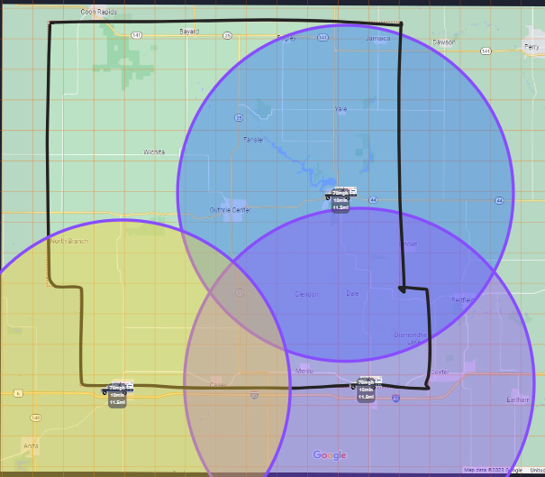
Solutions Proposed
- Develop a countywide service with the participation from all current services and cities over the next 5 years.
- Staff additional ambulance crews to:
  - Decrease response times through on duty ambulance depth and placement.
  - Decrease staff fatigue through call rotation.
  - Decrease reliance on outside services during high call volumes or multi-patient events.
- Develop EMS first responders within each fire department in the county.
  - Help with recruitment and retention.
  - Provide training and other operational support.

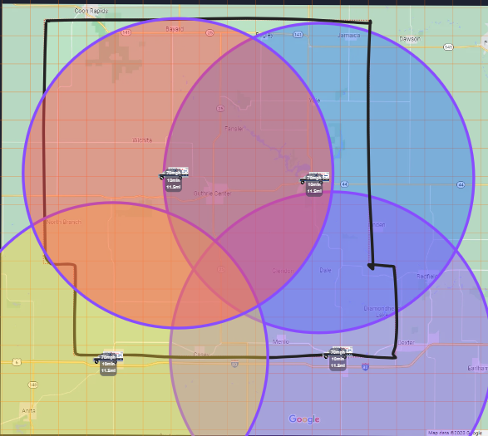
Proposed EMS Services timeline for Guthrie County Residents
Year 1-3 (start 2025 – 2030 for funding from the tax levy) some items can be done prior to the money coming in
- Establish and approve a county wide EMS tax. – currently happening now
- Hire EMS coordinator for the County. – will have to find funding until the tax levy
- Initiate 28E agreement with existing Ambulance Services for county subsidization of operational expenses (services will still bill for services) and add additional on duty crews and roster depth.
- Align Medical Direction under single Countywide Medical Director.
- Align all ambulance services protocols and equipment.
- Initiate a county wide training program. – hope to provide the training this spring. DMACC is working with the group to set up dates. Anyone can come to the trainings that want to be an EMT. Offer it annual. Can pay for the training with the training. Suggestions – have the participate that takes it they must need to pass the test. Another suggestion to say they need to stay and work in the county. Depending upon the program, participants can take the test three times before other events can happen. DMACC price is the same cost no matter of how many participants. Classes can by hybrid – evenings, day time, streaming with instruction and then have skills be in person. 120 hours in total for EMT. 40 hours are clinical and rest is schooling and hands on. Basic skills, clinical testing and some paper test. Hoping to have the clinicals with local ambulances and hospital. Could also reach out to Cass County hospital or Creston hospital.
- Develop, grow, and/or support EMS first responders within fire departments in every town, township, or fire district and tie them back to county services to alleviate administrative strain at the fire department level.

Year 4 and 5
- Align billing and all administrative functions under county service. – Will keep the third-party biller for all services. Dallas County has a third-party biller but has an administrative side to follow up on unpaid claims to help bring up the revenue.
- Develop long term 28E agreements with cities to keep ambulances in cities and pay for use of facilities/ equipment along with hiring all EMS staff under new countywide service. No plan to move anything out of Panora and Stuart. This is to enhance services within the county.
Year 5-10 continued taxes for countywide service
- Replace, purchase, and upgrade equipment to county equipment.
- Reassess number of on-duty ambulances, and placement thereof, to best support county needs.

QUESTIONS – COMMENTS
- Develop 28 E can be broken if the cities want to back out of the EMS plan if they want to be a stand-alone service
- This plan will give us time to do this properly and provide financial stability for current service. Gives the cities something in writing to help with understanding of changes being proposed.
- October 9th will meet with City of Stuart
- Key element and needs to be high priority – Arber think the first 3 year to be covered for the whole county.
- Could put a station at the Guthrie County Landfill for the ambulance to service the west side of the county. County owns the property. Could start out with a day coverage until the tax funding comes in to make it 24 hours.
- Another suggestion would be fairgrounds. Hospital might work but they probably have to do some refiguring their area.
- Use township lines suggestion by state – that township could decide where they want either Guthrie County for the tax levy or
- Duties of the EMS - work on protocols with all services have them be on the type of guidelines, start the training schedules, all EMT would be trained and up to date, purchase medical equipment and supplies in bulk to save funding, work with the medical director. 28E for cities would state that they will work with the coordinator.
- Need to keep enforcing is that we are taking the whole county residents and the services need to be shared.
- 28E agreement will state they can not bill township for the services.
- Mark – break it down by township by township – might help with township understand the high cost of doing taxes this way. Or do a per capita - $215 per person for every person or $94.00 for ?????? at 75 cents
- Nice thing – you can’t say that I will never use the service (or someone in their family)
- Keep the names of the services.
- Have town hall meetings to explain these services.
- Need to be aware of how much money the tax will bring in – can’t give it all to the 2 cities in year 1 to 3.
- Council will make recommendation to the BOS. The BOS will determine on how much is to be taxed. Council would decide how the money is spent.
- Get a new powerful statement – on how coverage areas – response time. –
- Add structure for distribution for how the funding will be going to.

Arber will make changes and get out to members again to review before sending out to the cities. Link to a word documents. Members can make changes to. Send this proposal to all cities/towns in Guthrie County. Send it to townships for the proposals.

October 9 taking with city of Stuart. – on the regular agenda item for their regular meeting.

Meet with cities – get something to BOS to approve for suggestions. Start educating in January for the public. The plans could change if the cities are not willing to participate. Not sure throwing numbers at the beginning.
Mnium could be what they are currently getting from the townships once the levy gets approved by public.
Eventually the city will understand that they will see that they are going to save money but not lose services.

Motion by Bill 2nd by Don to end the meeting at 8:30 pm

- Call Meeting to Order -Roll call of members
- Approval of Agenda
- Approval of Minutes
- Review EMS Services Proposal
  - Funding options
    - Countywide
    - City/Townships
    - Amounts
  - Timeline
  - Coverage areas
- Discuss October 9th City Council Meeting with Stuart
- Discuss/Action
  - Information the Council requires for next meeting
  - Date/Time of next meeting
  - Adjourn meeting

